Android LF RFID Reader
副标题：Handheld Android LF RFID Reader with Barcode Scanner
Features
- CPU:8 core 2.0GHz, memory: 4G+64G
- Android 10.0 OS with open-development environment
- Supports 134.2KHz or 125KHz LF RFID frequencies
- Built-in 1D/2D Barcode Scanner for efficient data collection
- IP65 for rugged performance
- Includes GPS, NFC, and wireless connectivity (Wi-Fi, Bluetooth)
Android LF RFID Reader-1
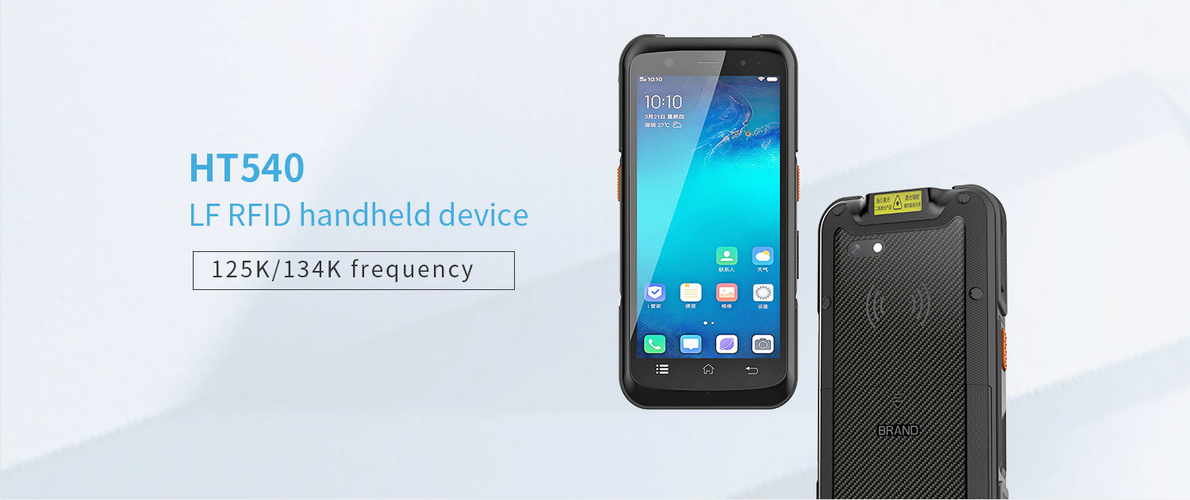
• The HT540-LF Android LF RFID Reader equipped with a powerful eight core MediaTek MT6762 CPU, with a maximum operating frequency of 2.0GHz per core, ensuring fast task processing. In addition, it is equipped with 4GB RAM and 64GB internal storage space, allowing for smooth switching between 15-20 active applications.
• The HT540-LF handheld Android LF Rfid reader is equipped with an LF Rfid module. The low-frequency RFID operates between 125kHz or 134kHz, with a communication distance of within 10cm, a data rate of 1-2kbps, and high stability. The signal has strong ability to penetrate non-metallic and non liquid materials.
• [Optional Scanning Function]: The HT540-LF 125khz rfid reader android supports an optional TMS-E60 scanning head，Support barcode and QR code scanning.
The HT540-LF low-frequency RFID handheld terminal has an IP65 protection level durable even in harsh environments such as warehouses or logistics operations.
Android LF RFID Reader-2
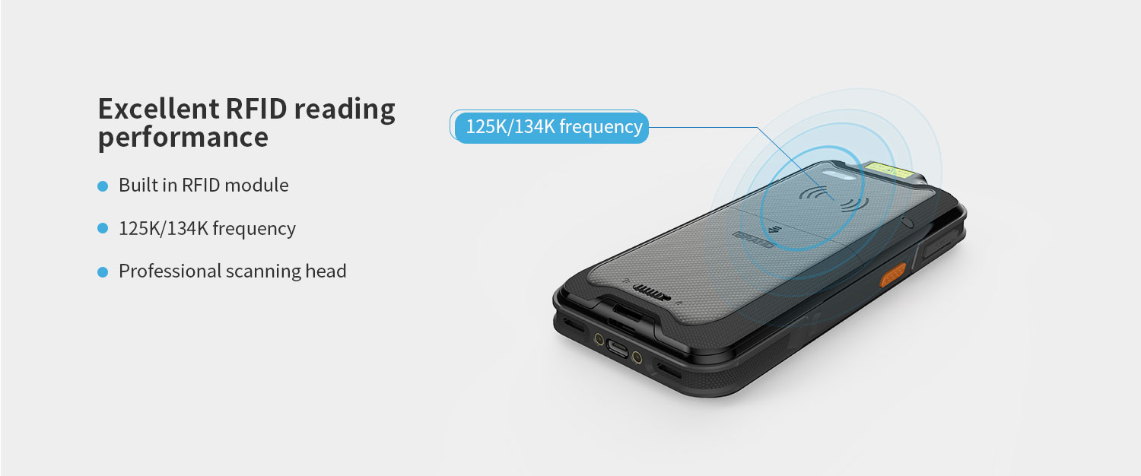
The HT540-LF Android LF RFID Reader terminal is equipped with an LF RFID module.
Operating frequency: 125KHz/134KHz (FDX-B/HDI)
Protocol: ISO 11784 and 11785
Android LF RFID Reader-3
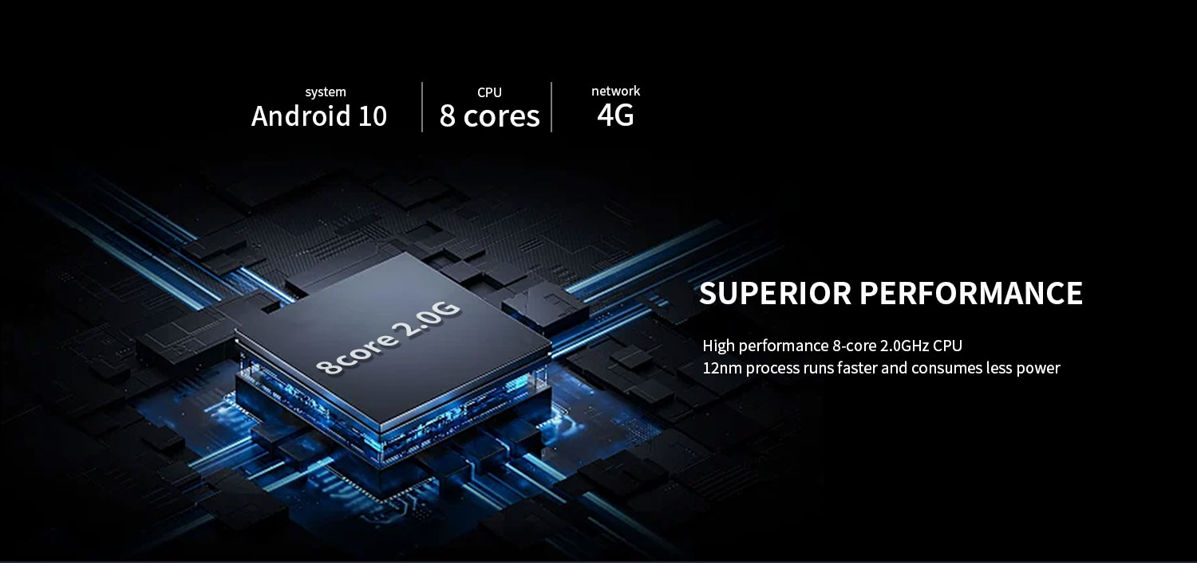
High performance CPU
MT6762 CPU: Experience the powerful performance of MediaTek MT6762, designed specifically for seamless multitasking on your PDA device.
Standard memory 3GB+32GB, optional 4GB+64GB: Use a high memory warehouse scanner to provide ample storage space for all your applications and files.

Android LF RFID Reader-4
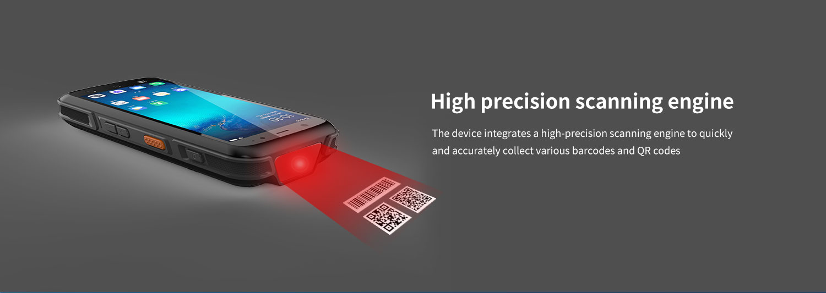
Scanning Engine - optional
HT540-LF Android LF RFID Reader supports optional TMS-E60 scanning engine, high brightness LED provides exposure assisted lighting, and can quickly recognize barcodes even in completely dark conditions. TMS-E60 provides laser aiming indicator patterns to assist users in aiming at targets, promote barcode recognition, and improve recognition efficiency. Capable of reading the most commonly used barcodes in the retail, logistics, and healthcare industries, such as Code 11, Code 128, PDF417, EAN codes, etc. It even supports scanning damaged barcodes and screen barcodes.
Supports optional Honeywell HS7 (with a motion tolerance of up to 6 meters/second (236 inches/second), capable of effectively reading mobile barcodes).
Android LF RFID Reader-5
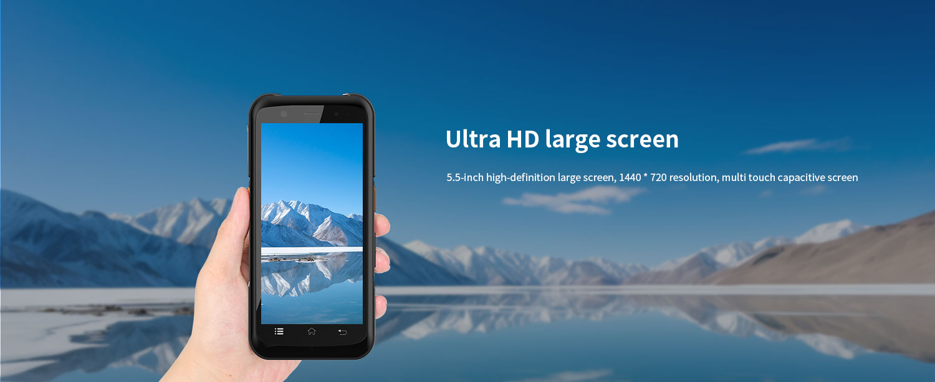
The HT540-LF Android LF RFID Reader is equipped with a 5.5-inch touch screen, which can operate the keyboard normally even when hands are wet or gloves are worn, making it more widely used.

Android LF RFID Reader-6
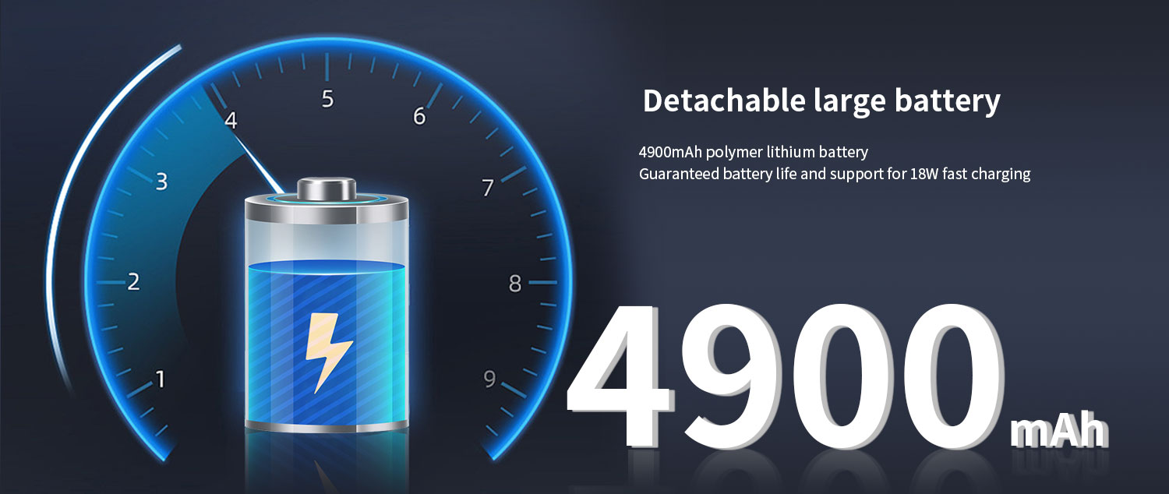
Android LF RFID Reader-7
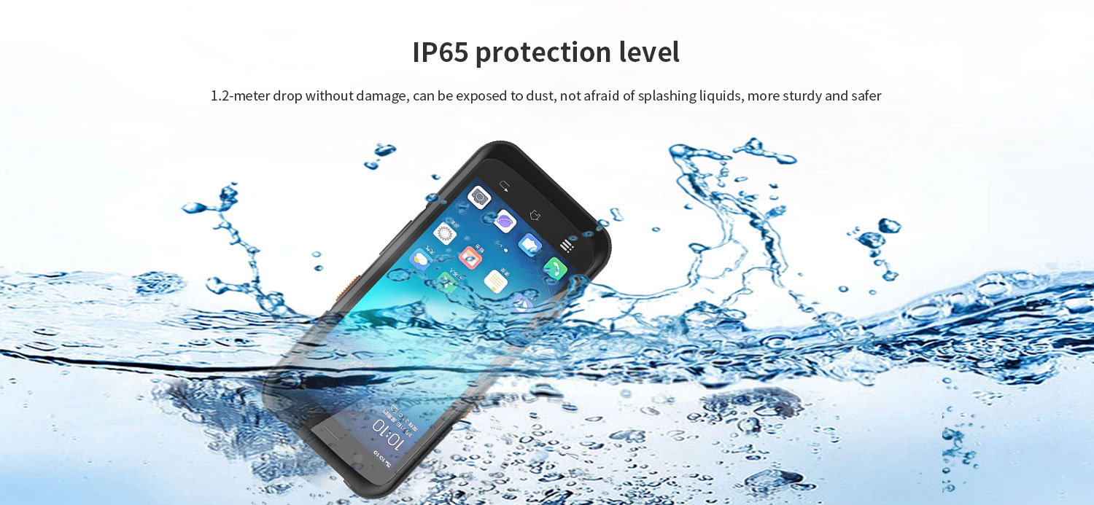
IP65 protection level
1. Dustproof: Fully enclosed design to prevent dust from entering and ensure the safety of internal components.
2. Waterproof: This HT540-LF Android 125kHz RFID reader has splash proof function, but should not be immersed in water.

The HT540-LF handheld RFID 125kHz RFID reader provides enhanced security, better performance, and a more user-friendly mobile operating system. Provide SDK development toolkit, demonstration software, and source code, support secondary development, and provide API interface customization.
Attention: We can help you test your application before making bulk purchases.

HT540-LF is a portable multifunctional Android LF RFID Reader that can meet different application needs. Android 10 operating system, equipped with high-performance 8-core 2.0G clock speed processor, 5.5-inch high-definition large screen, 13 million camera; 4GB+64GB memory. Supporting multiple optional functions: barcode scanning (optional scanning head), RFID module (optional) NFC, PSAM, IP65 protection level, adopting dual color injection molding process, with strong industry adaptability, widely used in various application fields such as logistics, retail, warehousing, medical, power, one card, parking fees, municipal engineering, etc., helping users quickly achieve information management and improve enterprise operation efficiency.


